

topsibog inventory system

Project Documentation Submitted to the Faculty of Computer Science and Information Technology of Asia Pacific College



August 24, 2016

ylaya,owen james d.

legaspi, ron eric j.

romero, kenneth G.

In partial fulfillment of the Requirements for the subject system analysis & detailed design

Contents

I. Narrative 2

A. Executive Summary 2

B. Introduction 3

1. Client Profile 3

2. Project Organization 4

3. Client’s Mission and Objectives 4

4. Project Objectives 4

5. Purpose of the Project 5

6. Rationale of the Project 5

C. System Features and Functions 7

1. Software Environment 7

2. Hardware Environment 7

3. Networking and Security 7

4. Application System Modules 7

II. System Diagrams and Screenshots 8

A. Data Flow Diagram 8

B. Context Flow Diagram 9

C. UML Diagrams 10

Class Diagram 10

Component Diagram 10

Deployment Diagram 11

Object Diagram 11

Package Diagram 12

Composite Structure Diagram 12

Use Case Diagram 13

Activity Diagram 16

State Machine Diagram 18

Sequence Diagram 18

Communication Diagram 18

Interaction Overview Diagram 18

Timing Diagram 18

D. Entity Relationship Diagram 19

E. Data Dictionary 20

F. Screen Shots 21

Lesson Learned 26

# Narrative

## Executive Summary

This Document was created to let the user know more about the system. The project was created for our current client which is Tapsibog was a small eatery before but grew to have many departments.

The Project team are comprised of 3 students from Asia Pacific College. These three were tasked to do system for Tapsibog inventory system after seeing how the existing system was. They have found some problems that need attention, these three people continued on developing the system. So far they are close to finishing it.

The Project team’s objective in creating this project was generally spin around the issue of viability and productivity. They made the framework to determine the issue our customer is confronting. This study is constrained to what they can create and come up for them. It concentrates on how they can help them improve their school much. The system features a function that helps the client organize its files and record. It also has a feature that lets the staff member access and input data in a database system.

Lastly the project runs on a Java programming language and HTML and in the local servers of XAMPP. The project is Windows based operating system. The project is only exclusive to the Tapsibog eatery; it cannot be accessed outside of the business premises.

## Introduction

* We created this inventory system to monitors the levels of inventory and determine the timeline and quantity of orders of Tapsibog eatery. Tapsibog wants to maintain inventories of raw materials, work in development or final products to maximize the profit of the business, including unpredictable raw material delivery time, allowing for production scheduling flexibility or demand variations, this system will help all the employee of Tapsibog to lessen the hassle of managing raw materials.
  1. A database used for storing and administering all types of data required for efficient and accurate warehouse inventory management. This may include modules or fields for keeping track of all items and locations, requisitions, back orders, required levels of inventory on hand, reorder points, lead times, inventory error tracking, and more. This type of system may interface with an ERP and other applications.
  2. Inventory Management must be designed to meet the dictates of market place and support the company’s Strategic Plan. The many changes in the market demand, new opportunities due to worldwide marketing, global sourcing of materials and new manufacturing technology means many companies need to change their Inventory Management approach and change the process for Inventory Control.
  3. Inventory Management system provides information to efficiently manage the flow of materials, effectively utilize people and equipment, coordinate internal activities and communicate with customers. Inventory Management does not make decisions or manage operations; they provide the information to managers who make more accurate and timely decisions to manage their operations.

### Project Organization

#### Project Team:

ylaya, owen james d. – project manager

legaspi, ron eric j. - member

romero, kenneth - member

#### Project Professor:

Sir Manuel Sanchez

### Client’s Mission and Objectives

##### Vision

Topsibog a eatery that want to be also a top fast food eatery that want to progress thru serving peoples quality choice of food without the ease of waiting, people will surely visit this eatery because of its quality tasting food.

##### Mission

In pursuit of Topsibog eatery. commits to:

1. Provide affordable quality Food through effective instruction by competent chefs under the leadership of the owner.
2. Inculcate love of God, Food, Humanity and Cleanliness.
3. Promote culture of competitiveness in all sectors of the Fastfood community.
4. Keep the learner abreast of technological, vocational and global trends and issues.
5. Enrich Chefs; competencies in bringing out their best as Cooks.
6. Commit the eatery as leading fastfood in the society.

### Project Objectives

* To ensure that the supply of raw material & finished goods will remain continuous so that production process is not halted and demands of customers are duly met.
* To minimize carrying cost of inventory.
* To minimize inventory ordering costs

### Purpose of the Project

* To keep inventory at sufficiently high level to perform production and sales activities smoothly.
* To minimize investment in inventory at minimum level to maximize profitability.

### Rationale of the Project

#### The Current Flow

The components of this study were accomplished through research and personal interview of the given client which is, Tapsibog eatery. By interviewing the said client, we found out that they do their process manually and that lead us to proposing a system. The current system they have because of those problems were deemed useless and they relied only with use of manual input and output, with those problems stated we thought of asking how the progress goes down among people inquiring and eating in the eatery. The process starts with owner buying stocks/ingredients for the availability of the certain product then the Main Cook will respond with details upon seeing the items and commonly order of customers, then after the customer gave its order he/she will pay the corresponding order and the eatery will issue an official receipt.

#### User Information Needs

* Raw Documents
* The users must be knowledgeable in using and how to deal with the system
* The greater parts of the System Clients are dependable in every activity that will be carried out in utilizing the System.
* Each client must have just 1 account which is made in a remarkable multi-level client sort like items, quantity etc.

#### How the Information is being processed

* The eatery is processing its stocks manually that takes a long time to know what ingredient is low or out of stock, so that we proposed this database system that will help them in properly organizing the products quantity for more profit.

## System Features and Functions

### Software Environment

#### Programming Languages

* Java
* HTML
* Mysql

#### Web Server Application

* XAMPP

#### Operating System

* Windows

#### Other Software

* Notepad++
* Paint

### Hardware Environment

* 2 GHz processor  
  RAM: At least 1 GB RAM  
  OS:Windows XP SP2, Windows Vista SP1, or Windows 7  
  Free Disk Space:4 GB

### Networking and Security

#### Security

* Login pages; Upon accessing the system, the user will be prompt to log in the system before they have access upon any other function or feature that the system is capable of.

#### Server

* Local Server XAMPP will be used.

### Application System Modules

* Viewing of stocks (ingredients)
* Updating and editing of system
* order Queries
* Adding of stocks
* Adding of quantity
* Adding of employee
* Updating profile
* Viewing of employee table

# System Diagrams and Screenshots

## Data Flow Diagram

## Context Flow Diagram

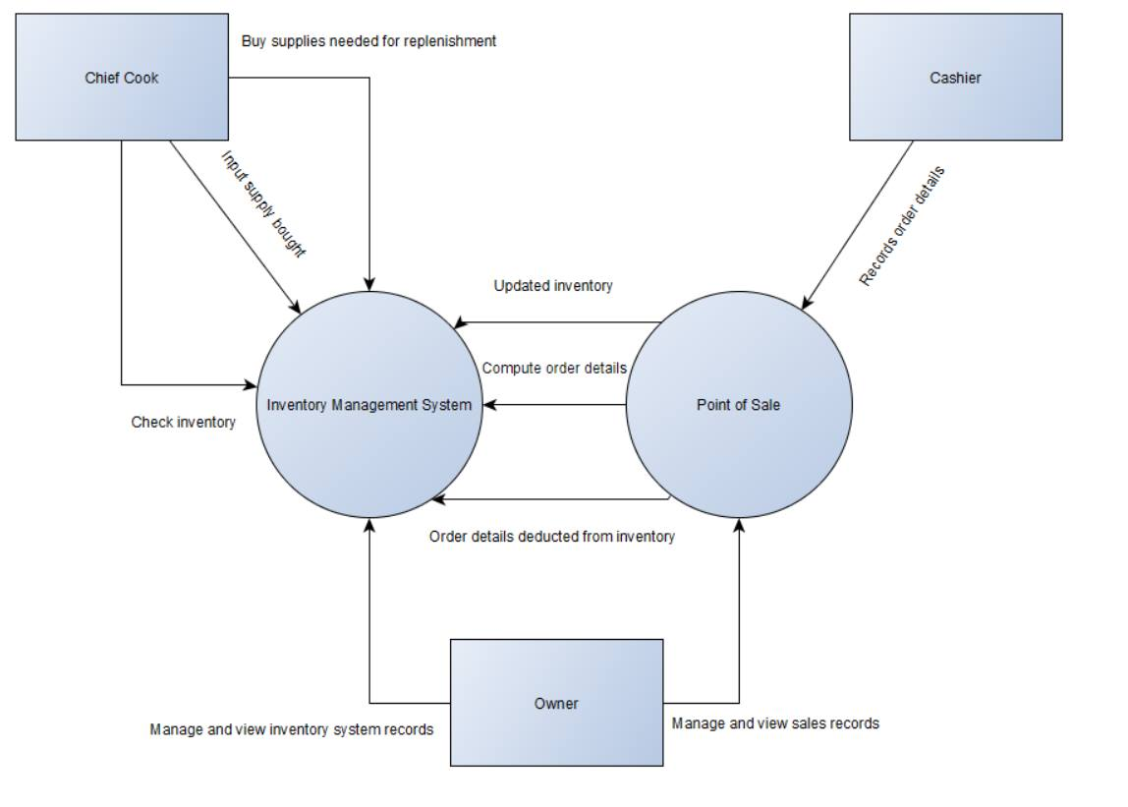

## UML Diagrams

### [Class Diagram](http://creately.com/blog/diagrams/uml-diagram-types-examples/#ClassDiagram)

### [Component Diagram](http://creately.com/blog/diagrams/uml-diagram-types-examples/#ComponentDiagram)

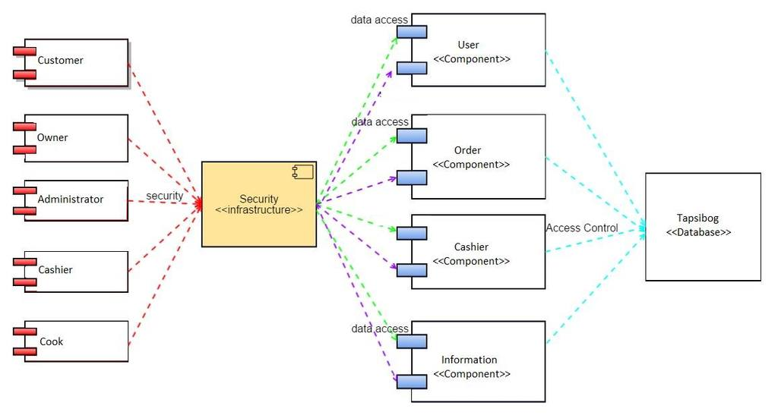

### [Deployment Diagram](http://creately.com/blog/diagrams/uml-diagram-types-examples/#DeploymentDiagram)

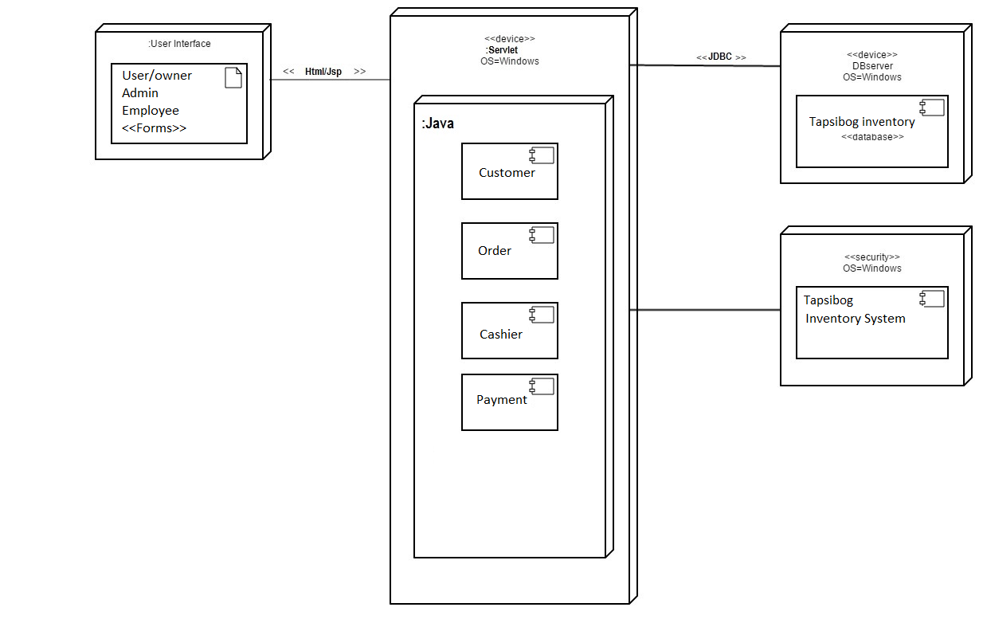

### [Object Diagram](http://creately.com/blog/diagrams/uml-diagram-types-examples/#ObjectDiagram)

C:\Users\Eric\Desktop\Sysadd\objectdiagram.png

Object Diagram of chief cook

C:\Users\Eric\Desktop\Sysadd\objectdiagraminventorychiefcook.png

### [Package Diagram](http://creately.com/blog/diagrams/uml-diagram-types-examples/#PackageDiagram)

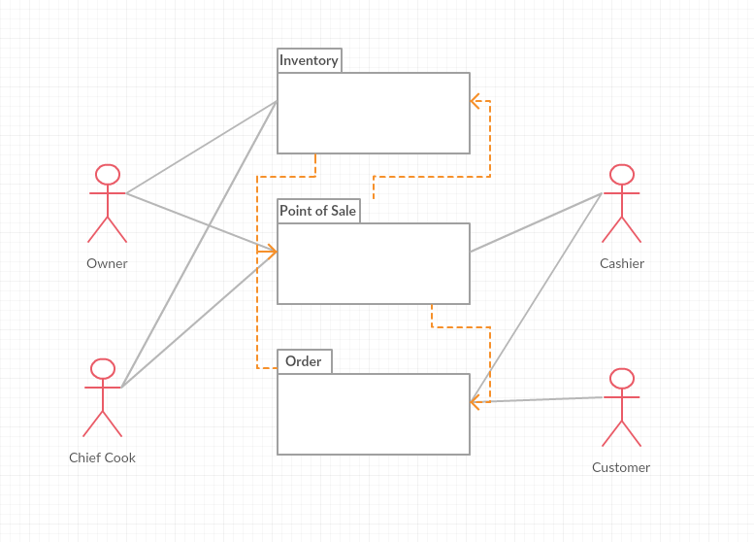

### [Composite Structure Diagram](http://creately.com/blog/diagrams/uml-diagram-types-examples/#CompStrDiagram)

### [Use Case Diagram](http://creately.com/blog/diagrams/uml-diagram-types-examples/#UseCaseDiagram)

|  |  |  |
| --- | --- | --- |
| Use Case Name | Input supply count to inventory | |
| Scenario | Chief cook inputs supply he bought from the  market | |
| Triggering Event | input and record supply details | |
| Actors | Chief cook | |
| Stakeholders | Chief Cook | |
| Related Use Case | Check Inventory | |
| Pre-conditions | Chief Cook must have bought exact amount of supply needed  Chief Cook must convert and have portioned supply count | |
| Post Conditions | Chief cook enters converted amount of supply count | |
| Flow of Activities | Actor | System |
|  | 1. Chief cook opens system | 1.1 Display input page |
|  | 2. Chief Cook input details in supply | 2.1 Record supply and save |
| Exception Conditions |  | |

|  |  |  |
| --- | --- | --- |
| Use Case Name | Check Inventory | |
| Scenario | Evaluate remaining inventory supply | |
| Triggering Event | Check Inventory | |
| Actors | Chief Cook | |
| Stakeholders | Chief Cook | |
| Related Use Case | Input order details | |
| Pre-conditions | Chief Cook must open system  Chief Cook must evaluate remaining supply | |
| Post Conditions | Chief Cook must have counted remaining supply | |
| Flow of Activities | Actor | System |
|  | 1. Chief cook opens system | 1.1 Display input page |
|  | 2. Chief Cook inputs supply details in system | 2.1 Record and save supply |
|  |  |  |
| Exception Conditions |  | |

|  |  |  |
| --- | --- | --- |
| Use Case Name | Input order details | |
| Scenario | Cashier inputs order details of customer to Point of Sales | |
| Triggering Event | Recorded order details to PoS | |
| Actors | Cashier | |
| Stakeholders | Cashier | |
| Related Use Case | Order details deduct to inventory count | |
| Pre-conditions | Cashier must have customer's order details Cashier must enter order details in the Point of Sales | |
| Post Conditions | Point of Sales must have deducted the inventory according to the order details | |
| Flow of Activities | Actor | System |
|  | 1. Cashier enters order details of customer in the system | 1.1 order details recorded  1.2 order details deducted to the inventory count |
|  |  |  |
|  |  |  |
| Exception Conditions |  | |

|  |  |  |
| --- | --- | --- |
| Use Case Name | Order details deducts to inventory count | |
| Scenario | PoS records order details and deducts inventory count | |
| Triggering Event | Compute order details | |
| Actors | Point of Sale  System | |
| Stakeholders | Cashier | |
| Related Use Case | Check Inventory | |
| Pre-conditions | Correct order details must be entered in PoS  Deduct | |
| Post Conditions | Inventory successfully deducted from the order details in the PoS | |
| Flow of Activities | Actor | System |
|  | 1. Chief cook opens system | 1.1 Display input page |
|  |  |  |
|  |  |  |
| Exception Conditions |  | |

|  |  |  |
| --- | --- | --- |
| Use Case Name | Manage/View inventory system records | |
| Scenario | Owner reviews or manage recorded details in inventory | |
| Triggering Event | Manage/View inventory system records | |
| Actors | Owner | |
| Stakeholders | Owner | |
| Related Use Case | Manage/View Point of Sales | |
| Pre-conditions | Owner must successfully log-in as admin  Order details must be displayed in the system | |
| Post Conditions | Owner successfully managed/viewed inventory details | |
| Flow of Activities | Actor | System |
|  | 1. Owner opens system | 1.1 Displays recorded   order details |
|  | 1.Owner opens system | 1.1 Displays recorded order details |
|  | 2. Owner views inventory details | 2.1 Displayed inventory details |
| Exception Conditions |  | |

|  |  |  |
| --- | --- | --- |
| Use Case Name | Manage/View Point of Sale | |
| Scenario | Manage/View Point of Sale | |
| Triggering Event | Manage/View Point of Sale | |
| Actors |  | |
| Stakeholders |  | |
| Related Use Case |  | |
| Pre-conditions |  | |
| Post Conditions |  | |
| Flow of Activities | Actor | System |
|  |  |  |
|  |  |  |
|  |  |  |
| Exception Conditions |  | |

### [Activity Diagram](http://creately.com/blog/diagrams/uml-diagram-types-examples/#ActivityDiagram)

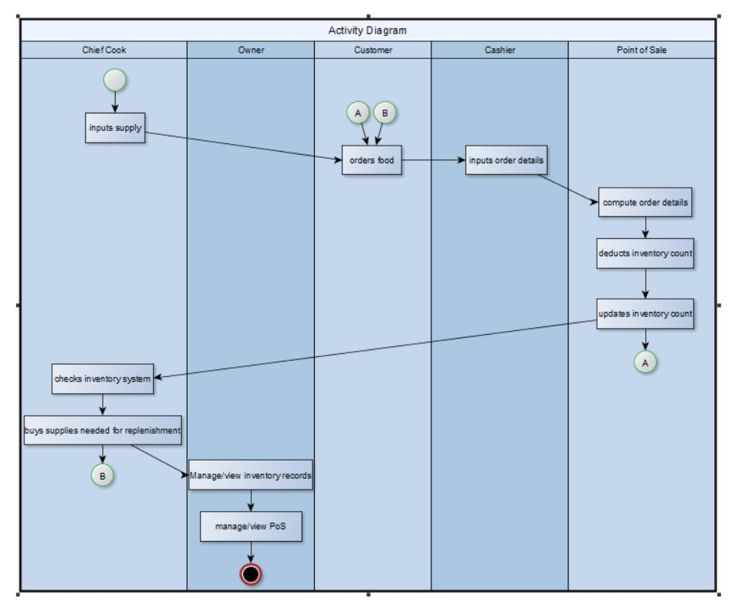

### [State Machine Diagram](http://creately.com/blog/diagrams/uml-diagram-types-examples/#StateMachDiagram)

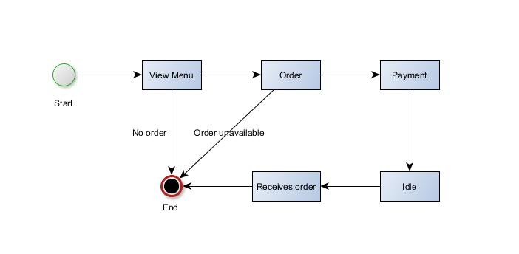

### [Sequence Diagram](http://creately.com/blog/diagrams/uml-diagram-types-examples/#SequenceDiagram)

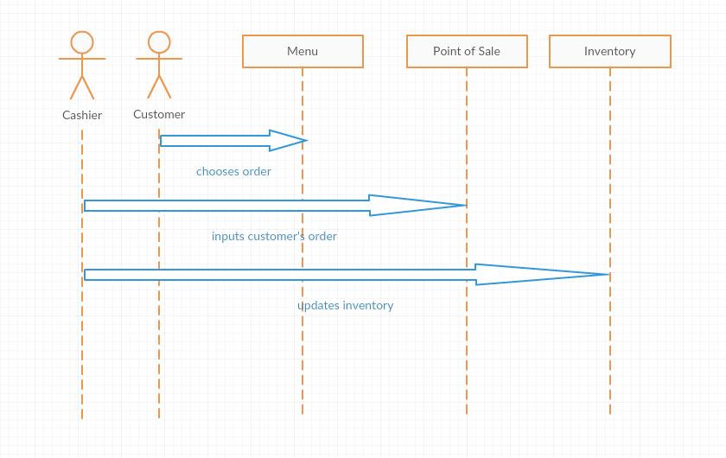



### [Communication Diagram](http://creately.com/blog/diagrams/uml-diagram-types-examples/#CommDiagram)

### [Interaction Overview Diagram](http://creately.com/blog/diagrams/uml-diagram-types-examples/#IntOverDiagram)

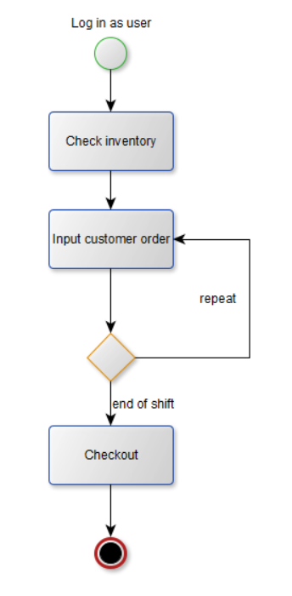

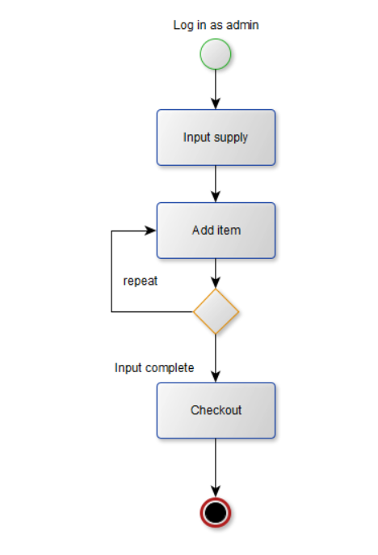

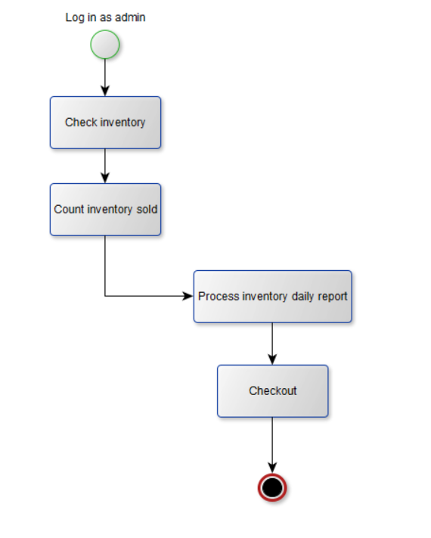

### [Timing Diagram](http://creately.com/blog/diagrams/uml-diagram-types-examples/#TimingDiagram)

C:\Users\Eric\Desktop\Sysadd\timingdiagram 1.png

C:\Users\Eric\Desktop\Sysadd\timingdiagram.png

## Entity Relationship Diagram

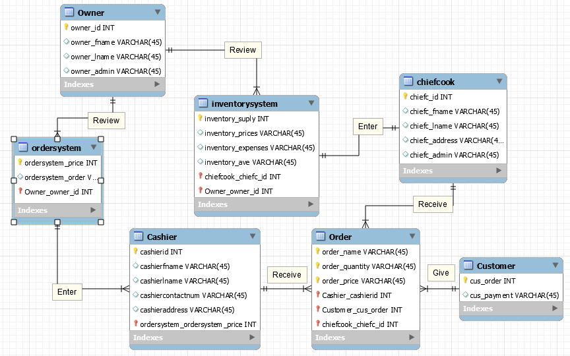

## Data Dictionary

## Screen Shots

## Lesson Learned

RON ERIC J. LEGASPI

* While making this project for consecutive terms, it goes without saying that this was obviously one of the most difficult tasks to complete. I have learned many things not just in making the project, but also in cooperating and communicating well with my fellow members. I learned that not only does gathering intel from clients are hard, it was also quite a huge milestone for us to keep up with. And that developing a system wasn’t quite easy as I thought it would be, and it made me realize that there are a lot more that needs to be done before finalizing with this kind of project

OWEN YLAYA

* Communication is the most important key in doing projects like this. Everyone in the group must have their own different tasks because other member might do the part where another person is also editing the same part of the project. Time management is also important. Project makers must avoid cramming because the project takes a lot of time even rushing might result to poor result.



KENNETH ROMERO

* While our project is far from over, our system is a mere prototype as of the moment, it has been quite a struggle doing everything along with all our other projects from other subjects. Time management has been poor as well as our communication with each other. But we can still improve and be better as a team and as individuals to make our client happy and pull off a great project.